Year 4: Recommended Books

In guided reading we like to expose children to a range of texts and genres. Below are some of the books that we have used extracts from so far this year.  Flood World (Thriller)  Set in a flooded future world, Tom Huddleston’s book is a thrilling adventure, in which two young people are caught up in a world of pirates, gangsters, power struggles and corruption. Kara and Joe live in a floating slum on the edge of what is left of London after rising seas have drowned our civilisation.  They’ve always been told that the Mariners, gangs who live entirely at sea, are terrorists. But then Joe’s life is saved by a Mariner, who entrusts him with a secret map. It’s a story that poses questions about our future, individual responsibility and the morals of political activism. Timely, thought-provoking, and action-packed.  The Light Hunters (Mystery)  From its enticing opening (“If there’s one thing I am absolutely and utterly sure about,” said Maya Murphy ducking under her desk on the classroom floor, “it’s that Mr Winter is a monster”), through its 300 pages of character-driven action, The Light Hunters is a stellar start to a new Middle Grade series.  At school, twelve-year-old Lux and best friend Maya are drilled in the art of what to do in the event of a monster attack. At home, Lux lives with his sick granddad, a clock repairer, and Miss Hart, Grandpa’s carer. Oh, and he’s also the most accomplished Light Hunter of all time and manages to save Maya when she’s gravely injured in a monstrous attack. But this brave act of friendship brings trouble, for it draws a mysterious stranger to town, someone who’s set on misappropriating Lux’s powers.  With Miss Hart’s guidance (for she harbours a secret…), Lux steps-up his training in the ways of Light Hunting as word comes of the impending attack of a monster to whom he’s painfully connected.  The Pearl in the Ice (Mystery)  Set in 1912, this action-packed adventure feels both classic and contemporary, with Marina, its young heroine, yearning to break free from societal constraints to become the “new woman” she’s read about in modern magazines. Namely, the kind of woman who is “mistress of her own destiny”. Frustratingly, Marina’s father dismisses her desires outright. Being a naval captain he’s often away at sea and, with her mother gone, Marina is about to be shipped off to boarding school when all she really wants to do is set sail with her dad. So much so, Marina ends up stowing away on his ship. As his mission is vitally urgent, Captain Denham has little choice but to continue with Marina aboard.  As their perilous voyage progresses, the thrilling dangers of enemy sightings, superstitious shipmates and icebergs are interlaced with myth and mystery as Marina feels an inexplicable “urgent tugging in her chest to go north” after being accused of possessing the power to “call up storms”. Indeed, Marina’s affinity with the sea adds an extra edge of intrigue throughout, leading to an eerie explanation as the novel twists and swells to its pulse-quickening crescendo.  Chase (Sci-Fi)  Chipper is a very special dog. As part of a top-secret, multi-million dollar experiment to create the ultimate canine spy technology, Chipper's whole life has been spent within the walls of a secret organization known only as The Institute. Chipper is supposed to be more machine than mutt, but something's wrong and The Institute knows it. He's about to be terminated.  Across the state, twelve-year-old orphan Jeff Conway is working all hours at his aunt Flo's lakeside cabin business. He misses his parents, his old life, and the dog he had to leave behind. When Chipper escapes and Jeff finds himself part of the chase, The Institute's most ruthless agent is hot on their tail, and he wants Chipper dead ...at any cost.  The Velvet Fox (Enchantment)  It’s autumn and the happiness and warmth of manor house Plas-y-Fran, now home to orphan Seren, is about to be disturbed by the arrival of the sinister Tylwyth Teg, or Fair Family. First, it’s Mrs Honeybourne in her red, velvet gloves, claiming to be a governess for Seren and her friend Tomos, but even stranger and much more frightening figures follow. Can Seren stand up to the Fair and save Tomos and her adopted family?  A story of danger, courage and strength, Seren’s adventures will send delicious shivers down the spine. Catherine Fisher is a superb storyteller, breathing new life into old stories and setting them free like the wind whirling autumn leaves. This is the second story about Seren and also stars her magical clockwork companion Crow but stands on its own. Highly recommended especially for winter nights.  If you like this, you’ll like Amy Wilson, Sophie Anderson and queen of magical stories, Diana Wynne Jones.  Mirroculist Mission (Fantacy)  This exhilarating sequel to Monsters in the Mirror follows 11-year-old Darwen’s second fantastical quest. In possession of a magical mirror that acts as a powerful portal to the breath-taking realm of Silbrica, Darwen previously defeated a host of monsters that came through the mirror. He must now journey to spectacular Costa Rica to battle a terrifying tentacled beast.  The stakes are high, the action is perfectly paced, and the friendship between Darwen and his companions is authentic and engaging. Alongside these essential ingredients of Middle Grade adventure, the evocation of nature and landscape is wonderful – the “rainbow-coloured waterfall, which strobed first turquoise, then emerald green, then a yellow bright as liquid gold”; trees sprouting “slim, silvery leaves that rustled like foil in the breeze”. Moreover, not only is this a gripping adventure, but it’s visually pleasing too - invitingly-designed and further enlivened by Manuel Šumberac’s atmospheric illustrations.  The Somerset Tsunami (Historical Fiction)  Emma Carroll brings her own Somerset countryside vividly to life in this enthralling tale and you can even detect the West Country tones of her spirited young heroine, Fortune Spicer, as you read. Fair Maidens Lane, where she lives, is a successful hamlet running well, despite an absence of men. But as the story opens a matriarch is arrested. An atmosphere of suspicion is spreading across the land from King James’ obsession with witches and unscrupulous men are using this as a weapon for financial gain.  Sent away by her mother, disguised as a boy for her own protection, Fortune ends up as a servant at Barrow Hall only to find a master even more against witches than the king, but also happy to exploit the opportunity to raise funds for a terrible new trade in human beings.  When the natural disaster overtakes them all, Fortune survives, but must fight torture and a trial for witchcraft to prove she is not to blame for the flood. The claustrophobic atmosphere of male oppression, corruption and real menace is wonderfully well done, and Fortune is a redoubtable heroine learning to have faith in herself and to seek her own destiny. As with all her novels this author wears her research lightly but provides a genuine learning experience and a genuine feeling for the period and for the characters she brings so memorably to life.  Cloudburst (Environmental)  Young readers who want to be gripped, challenged, informed and entertained – this exciting new adventure series is just what you’ve been waiting for. Fourteen-year-old Jack is on a safari holiday in the Democratic Republic of the Congo with his parents, the wealthy founders of a conservation charity. His friends Amelia and Xander are on the trip too – so far, so idyllic (though he could do without his arrogant cousin Caleb), but then his parents are kidnapped by mercenaries.  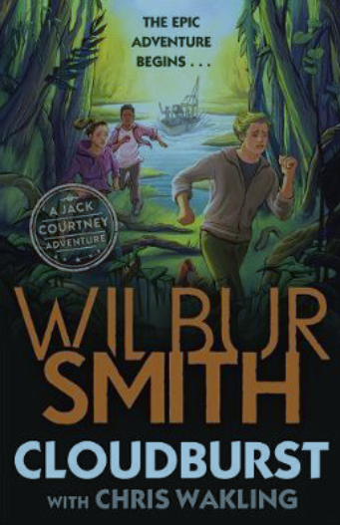  Jack has already experienced one family tragedy, he’s determined he’ll prevent another. This is a taut, tightly plotted thriller which puts young people firmly in the driving seat, but there’s lots about family and relationships too. Moreover, the authors will inspire a fascination about the wildlife of the region in readers, and alert them to the threats facing it. Fast-moving adventure with heart and a message.  Fizzlebert Stump and the Bearded Boy (Adventure)  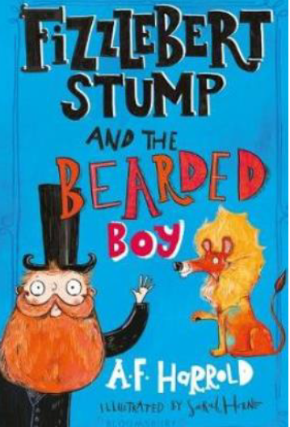  Fizzlebert Stump’s Circus is back for a second riotous show during which everything can – and does – go terribly wrong. The new act features the very, very hairy Barboozul family which includes Wystan, the bearded son. Fizzlebert - his mum is a clown and dad is a strongman - is used to oddities but he has never come across a bearded boy.  Will the two become friends? Many strange things happen at the Circus before anything as obvious as that happens in a delightfully chaotic and imaginative romp.  Rumble Star (Magical)  As proved in her hugely popular Dreamsnatcher series, Abi Elphinstone understands exactly what young readers want in the way of magical adventure and Rumblestar, the first instalment of a new series, should make them very happy indeed. The new Unmapped Chronicles start with a ‘what if’ - specifically what if our climate was actually created magically in another world linked to ours? When Casper Tock finds himself in just such a world, all he wants is to escape but it’s his destiny to stand against the villainous Morg to safeguard his home. In this he has a wonderfully spiky companion, a girl called Utterly Thankless, and a whole host of dangers to confront.  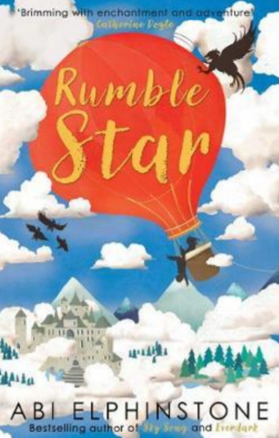  The adventures keep coming and Elphinstone’s imagination seems boundless while she’s clearly thinking too about the climate challenges we face in the real world. Great stuff, and a real treat for young readers.  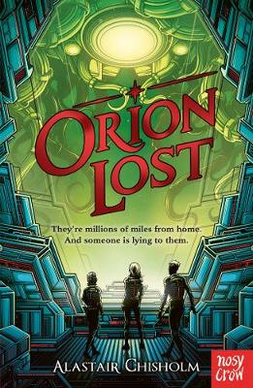  Orion Lost (Adventure/Science Fiction)  If you like Star Wars, you’ll love Alastair Chisholm’s space adventure.  The action takes place on board the transport ship Orion as it heads out from Earth to a new colony far away. Reaching their destination requires ship and passengers making a series of Jumps through space and time, and surviving a Jump means entering a state of deep suspended animation. Emerging from one of these, Beth discovers that none of the adults can be woken, and that she is now acting captain with a ‘crew’ of fellow youngsters. There are tensions between the children, some alarming encounters with aliens and – much more terrifying – space pirates, all made worse when Beth begins to suspect that the ship itself may not have their best interests at heart. It all makes for a terrifically taut and entertaining page-turner, with twists and surprises galore. Don’t miss! | 