Year 3 Science Project
Plants

In our science project this week we want you to explore plants by doing some of your own research and carrying out investigations at home. Each day you will be given a different theme and ideas for investigations. You do not have to complete all of the activities. These are ideas of what you could do to find out more, explain what you know or to just have fun exploring science!

You can present your work however you want - the more creative the better! You can take photographs, videos, produce artwork, write poetry, draw graphs, make a book (to name just a few). We would love to see your hard work so please send us an email on the class accounts 3E@ashdeneschool.net or 3S@ashdeneschool.net or post on the school twitter account.

Useful websites to visit

https://www.bbc.co.uk/bitesize/clips/zsdkjxs
https://www.theschoolrun.com/learning-about-plants-in-primary-school
https://www.coolkidfacts.com/plant-facts-for-kids/

IMPORTANT INFORMATION – PLEASE READ
You should ALWAYS wash your hands after handling plants (including seeds), soils, composts, manures, equipment and other a related materials
• Plants (or parts of plants) can be poisonous, cause allergic reactions in some people or may have been treated with chemicals (such as pesticides). Always ask an adult before handling plants.
• You must NEVER eat plants, unless given instructions that you may do so by a trusted adult.
• Wild flowers should not be picked and it is illegal for anyone (without the permission of the landowner or occupier) to uproot any wild plant

Monday – What does a plant need to survive?

- First, you are going to look in your house and garden at all the different plants you have and their features. To record this, you could do it in a tally chart. For example:
Type of plant | Tally
Plants with only leaves | IIII
Plants with flowers | II
Plants in pots | IIIII IIII
Plants planted in the ground | IIII
Trees | II
Bushes | IIIIII

You don’t have to use the groups/ classifications in the example, you can make your own up.

- Today you are going to investigate what a plant needs to survive and set up an experiment. Watch this video to see what plants need to stay alive: https://www.youtube.com/watch?v=_RXVhiUnTA8

Activity ideas
Investigation
Can your plant survive?
Check with a grown up if you can take a plant and see if it can survive without one of the following: air, light, water, nutrients from soil and space to grow (all things mentioned in the video).
Choose which one of the requirements for life you are going to remove and how you are going to do this. For example, to remove light you can place your flower in a dark place for example a kitchen cupboard. For air, you can cover the plant with a plastic bag (like in the video) or adjust the temperature by placing it on or next to a radiator. IMPORTANT – you need to make sure that your plant still has all of the other things it needs to survive, otherwise you won’t be conducting a fair test!
Predict what will happen to your plant. You can do this by drawing a picture or writing a prediction of what you think you plant will look like at the end of the experiment.
Just for fun!
Design your own plant  Create your own plant based on things you love to do! It could be a football plant or a dancing plant.  What does your plant need to survive? | Online plant  Play this game to see if you can keep the plant alive: https://www.sciencekids.co.nz/gamesactivities/plantsgrow.html

Tuesday – identify and describe the functions of different parts of a flowering plant

- Give yourself 1 minute to try and name as many different parts of a plant that you already know….GO!

- Watch the video below to check your answers and complete the quiz:
https://www.bbc.co.uk/bitesize/topics/zy66fg8/articles/zcjnp39

Activity ideas

Can you explain the different parts of a plant?
Have a look at the PDF (link below) of parts of a plant to help you with this
Create your own video  Make your own science video to explain the different parts of a plant and their functions. | Plant poetry  Write a poem about the different parts and functions of a plant.
Just for fun!
Make your own 3D plant poster
Make your own 3D plant model using items from around the home. For example you could use a sponge for the roots because the roots absorb water from the soil, or a straw for the stem because water travels up the stem (like a straw).

PDF:

file:///R:/Corona%20Virus%20Planning%20Folder/Lower%20KS2%20Class/Week%209/Parts%20of%20a%20Plant%20PowerPoint.pdf

Wednesday – how water is transported within plants

- Your first task for today is to check how your plant from Monday’s experiment is doing. Record any changes that have happened so far.

- Yesterday you looked at the different features of a plant. Today you are going to look at how water is transported within plants. Watch this video to discover more about water transportation in plants:
https://www.bbc.co.uk/teach/class-clips-video/science-ks1-ks2-ivys-plant-workshop-how-does-water-get-from-the-roots-to-the-leaves/zdtfjhv

- Now you know more about this, you are going to set up your own experiment.

Investigation
How water is transported within plants
For this experiment you will need the following:
Celery (with the leaves still on)
Food colouring – you may have this at home already but if not, you can buy it from the supermarket. Dark colours are best e.g. blue/red/green
A glass/container big enough to stand the celery in
Cold water
A spoon for stirring
An adult to help you
Patience!

All the details on how to do this investigation are found in the link below
http://www.teaching-tiny-tots.com/toddler-science-celery-experiment.html

Make some predictions about what you think might happen and write them down so you can see if you were right later on. Remember you will need to wait at least 24 hours to see the biggest results but you can keep checking back on your experiment to make any observations.

Just for fun!
Straw stem game  Be a human stem and see how much water you can transfer from one cup to another in two minutes by sucking up through your straw and dropping it into an empty cup. Play in teams with other members of your house. You can also try using other things such as sweets or maltesers! | Same or different  Looking at different flowers in your own garden or whilst on a walk, examine the stems. Make some notes on what is the same and what is different between different flowers.
Activity ideas

Thursday – different types of plants

Today, your task is to find as many different plants as you can. Go for a walk with your family and see how many different species of plants and flowers you can find. We are setting you a challenge to see if you can find some of the following:

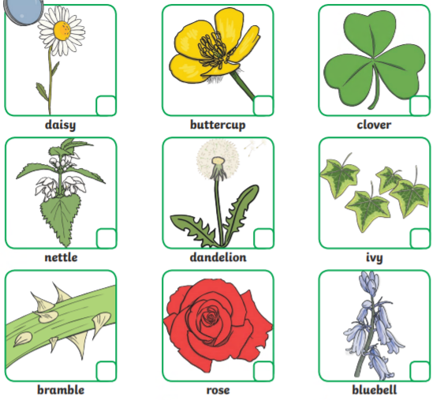

Activity ideas
Recording your find
Take photos  Take as many pictures as you can of plants and flowers on your walk and compare the similarities and differences between them e.g. colours, size, stem, leaves. | Rainbow picture  Pick some plants and flowers on your walk and make a rainbow picture using the petals, stems etc. | Design a leaflet  Create a leaflet on the different plants and flowers you have found on your walk. Label the different parts using the knowledge you now have. You can also find out some fun facts using google.

Friday – The Life Cycle of flowering plants

- Your first task is to check on your plant from Monday’s experiment. Record the changes that have happened over the last five days. Look back at your prediction, were you correct? Record this in your books. You can keep this investigation going into next week if you don’t think you’ve seen much of a change in your plant.

- You are going to look at the life cycle of a flowering plant and how plants start out as seeds, how they grow and how they help to produce new plants of their own. Click on the link to find out more information:
https://www.bbc.co.uk/bitesize/clips/zgqyrdm

- You can then present the information you have found out about the life cycle using one of the activity ideas below.

Activity ideas
Presenting your findings
PowerPoint  You can create a PowerPoint on the life cycle of a plant. Try and use pictures and as many of the scientific vocabulary as you can to explain the process. | Presentation  You can make your own presentation explaining the life cycle. Get creative as you want to – you might want to use members of your family to represent the seed or the insects! | Poster  You can create a poster explaining the different stages of the life cycle. Draw and label pictures.
Just for fun!
Bees are incredibly important to the life cycle of plants and making sure new plants are produced. Click on the link to find out more about bees and the important job they have.
https://www.bbc.co.uk/bitesize/topics/zy66fg8/articles/zx4ktv4

There are 267 species of bee in the UK. See how many you can find in your garden or on a walk. Some to look at for are:
