Monday - Prediction

- Look at the title of the book. What are your first thoughts about what this book might be about?
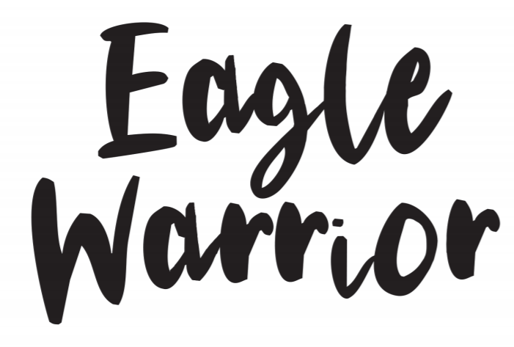
The title makes me think the book could be about… because…

- Now look at the front. Does this change your first impressions? What do you think the book might be about and where do you think it could be set?
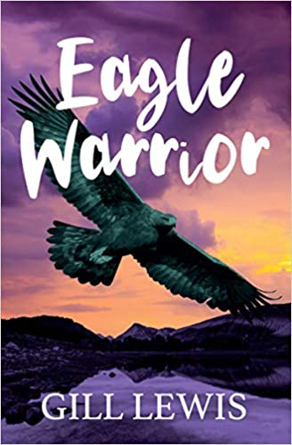

Looking at the front cover, I now think…
I think that the book could be about…
I think the book might be set…

- Look at the blurb. What do you know think the book will be about? What genre do you think this book is? Explain your thoughts.

Bobbie lives on a sheep farm in the Scottish Highlands with her parents and strong-willed, somewhat eccentric grandma. In a shocking opening chapter, Granny’s little dog dies suddenly and horribly, poisoned by bait intended to kill a magnificent young golden eagle. Bobbie and her granny know that the local landlord’s gamekeeper is responsible, and that he’s a threat to all birds of prey in the area. Can they prove it, and protect the eagle?
Reading the blurb, I now think… I think this is a …… book because …

- Thinking about the information you have taken from the title, front cover and blurb. Do you think this book might be like any other books you have read before? Why?

I think this book might be similar to…………………..because………..

