Vocabulary Tuesday

- Find the below vocabulary in the extract.

Wood burner
Scowled
Moorlands
Haggis
Bleated
Valley
Duke

- Write down and find the definition for any other unfamiliar words.

- Match the vocabulary you have found in the text with the definitions and pictures below.

Definitions
a Scottish dish consisting of a sheep's or calf's offal mixed with suet, oatmeal, and seasoning and boiled in a bag, traditionally one made from the animal's stomach.
a low area of land between hills or mountains, typically with a river or stream flowing through it.
an extensive area of moor.
an angry or bad-tempered expression.
a male holding the highest hereditary title in the British and certain other peerages.
a heater or stove that is fuelled by wood.
make a characteristic weak, wavering cry (usually a sheep, goat, or calf).
Pictures
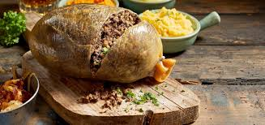
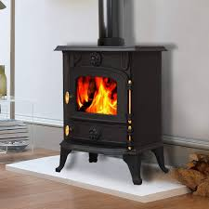
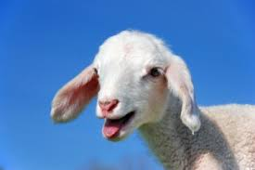
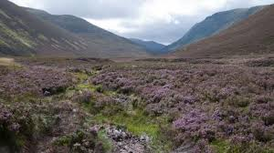
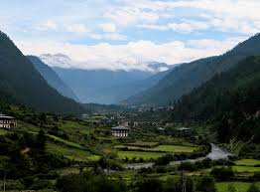

ANSWERS
Haggis | a Scottish dish consisting of a sheep's or calf's offal mixed with suet, oatmeal, and seasoning and boiled in a bag, traditionally one made from the animal's stomach.
Velley | a low area of land between hills or mountains, typically with a river or stream flowing through it.
Moorlands | an extensive area of moor.
Scowl | an angry or bad-tempered expression.
Duke | a male holding the highest hereditary title in the British and certain other peerages.
Wood-burner | a heater or stove that is fuelled by wood.
Bleat | make a characteristic weak, wavering cry (usually a sheep, goat, or calf).
Haggis
Duke
Wood Burner
Bleat
Moorlands
Valley
Scowl

