Wednesday - Retrieval
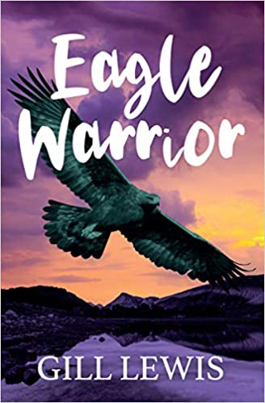
1) Read the Eagle Warrior extract again.
2) Answer the questions below. Scan the text for key words in the questions to help you find the answers.

1. | Who was Haggis?
2. | Where did Granny live?
3. | Describe the inside of Granny’s garden shed.
4. | What did Granny look like? Why?
5. | What does Granny give to Bobbie before she leaves to go up the hill?
6. | Which was the only lamb or sheep not to move away?
7. | Who gave Bobbie her coat?
8. | Why did Bobby love her coat?
9. | Who owned the land where the farm sat?
10. | Where was the golden eagle resting?
11. | What mobbed the golden eagle?
12. | Where was Haggis eating the dead rabbit?

Answers
1. | Who was Haggis? | Granny’s dog
2. | Where did Granny live? | The garden shed
3. | Describe the inside of Granny’s garden shed. | It had big windows that looked out across the fields to the moorland and mountains. There was a bed, an armchair and a table, and a wood burner.
4. | What did Granny look like? Why? | A mountain. Her face was full of wrinkles, like a craggy rock. She had wisps of snow-white hair on top of her head. She stomped in her big boots across the Scottish hills as if she was a mini mountain troll.
5. | What does Granny give to Bobbie before she leaves to go up the hill? | A pair of binoculars and Haggis to walk.
6. | Which was the only lamb or sheep not to move away? | Mavis
7. | Who gave Bobbie her coat? | Granny
8. | Why did Bobby love her coat? | It had lots of pockets. It had pockets inside pockets. It even had pockets inside pockets inside pockets. She could hide a whole packet of biscuits without Mum seeing.
9. | Who owned the land where the farm sat? | Charles Hunt, the 10th Duke of Glen-Gallows.
10. | Where was the golden eagle resting? | Near the top of a pine tree
11. | What mobbed the golden eagle? | Two ravens
12. | Where was Haggis eating the dead rabbit? | On the other side of a stream

