Monday - Prediction

- Look at the title of the book. What are your first thoughts about what this book might be about?
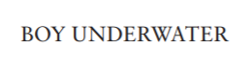
The title makes me think the book could be about… because…

- Look at the picture and tag line from the front cover. What do you think this suggests may happen in the story?
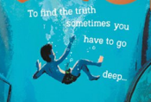
I tag line, ‘To find the truth sometimes you have to go deeper,’ suggests that the book might be about…

- Now look at the front. Does this change your first impressions? What do you think the book might be about and where do you think it could be set?
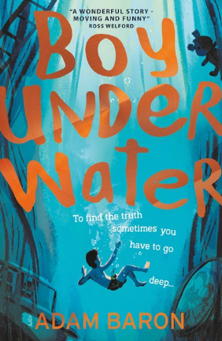

Looking at the front cover, I now think…
I think that the book could be about…
I think the book might be set…

- Look at the blurb. What do you know think the book will be about? What genre do you think this book is? Explain your thoughts.

Cymbeline (yes, really!) has never been swimming - not ever, not once - so he's a bit nervous at the prospect of his first school swimming lesson ever. But how hard could it be? He's Googled front crawl and he's found his dad's old pair of trunks. He's totally ready for this. But he's not ready for an accident at the pool to reveal a family mystery that turns his life completely upside down. Only Cym and his friends can solve it because, as usual, the grown-ups aren't telling them anything. For the answers you really need, sometimes you have to go deep .

.Reading the blurb, I now think… I think this is a …… book because …

