Vocabulary Tuesday

- Find the below vocabulary in the extract.

Allergic
Lochs
Chlorine
Convincing
Overwhelming
Horror
Butterfly

- Write down and find the definition for any other unfamiliar words.

- Match the vocabulary you have found in the text with the definitions and pictures below.

Word | Definitions
 |  | To load or burden with too much of something.
 |  | A substance that is one of the chemical elements. It combines with sodium to form table salt. It is also used in making bleach and is commonly used in swimming pools to kill bacteria.
 |  | In Scotland, a lake, or an arm of the sea that is largely surrounded by land.
 |  | A vigorous swimming stroke performed face down in which the arms are lifted simultaneously forward and brought back through the water while the legs move simultaneously up and down.
 |  | Caused by or relating to an allergy.
 |  | A great and painful feeling of fear or shock.
 |  | to cause to believe or accept
Pictures
 |  | 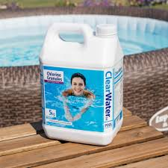

ANSWERS
Definitions
Overwhelm | To load or burden with too much of something.
Chlorine | A substance that is one of the chemical elements. It combines with sodium to form table salt. It is also used in making bleach and is commonly used in swimming pools to kill bacteria.
Loch | In Scotland, a lake, or an arm of the sea that is largely surrounded by land.
Butterfly | A vigorous swimming stroke performed face down in which the arms are lifted simultaneously forward and brought back through the water while the legs move simultaneously up and down.
Allergic | Caused by or relating to an allergy.
Horror | A great and painful feeling of fear or shock.
Convince | to cause to believe or accept
Pictures
Convincing

Chlorine

Horror

Lochs

Butterfly

Overwhelming

Allergic

