Use the picture from yesterday and the story starter to complete today’s task.
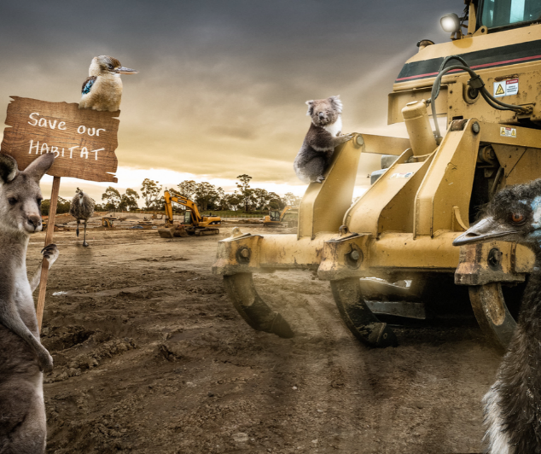

Story starter!
“Leave us alone! This is our home!” the animals all declared as one.
The humans didn’t seem to care…

Today you have a choice as to how you present your writing.
You can either continue the story,
Or, you can try and persuade the humans to leave the animals alone? This could be a persuasive poster, leaflet or even a letter.

