Look at the picture below and complete the tasks below.
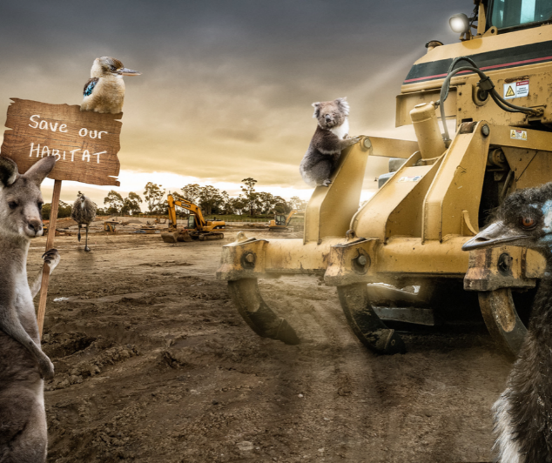
Task 1 Questions
What is a habitat?
What is happening in the picture?
Do you think it is fair?
Which animals can you see?
What country do you think the picture is from?
Do you think there are any important messages to take from this picture?
If you were driving the digger, how would you feel? What would you do?

Task 2
Can you write a paragraph to persuade humans to treat animals with respect?
You could start with:
It is important that…
It is appalling that...
You could include a rhetorical question:
Did you know that... ?
How can we... ?
Will you...?

