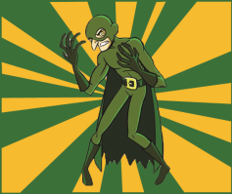**Adverbial Phrase**

A **Phrase** which answers **How? Where?** or **When?**

**Finish each sentence by adding an Adverbial Phrase:**

**Where?**

The beast dribbled __________________________________________________________________________________

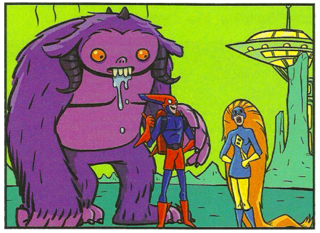

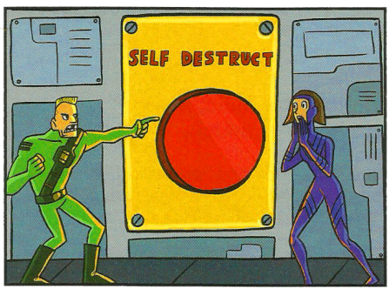

**How?**

The stupid man pressed the self-destruct __________________________________________________________________________________

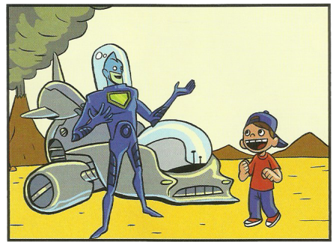

**Where?**

The alien landed __________________________________________________________________________________

**Write a sentence, including an Adverbial Phrase, for each picture:**

**When?**_____________________________________________________________________________**Where?**_______________________________________________________________________________________

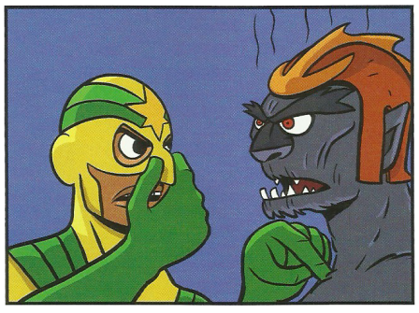

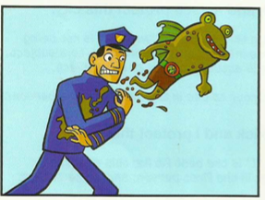

**Where?**____________________________________________________________________________**How?**_______________________________________________________________________________________

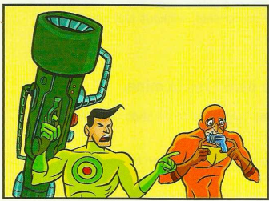

**Where?**____________________________________________________________________________**How?**_______________________________________________________________________________________

**Where?**____________________________________________________________________________**How?**______________________________________________________________________________ **When?**_____________________________________________________________________________

