Number 28
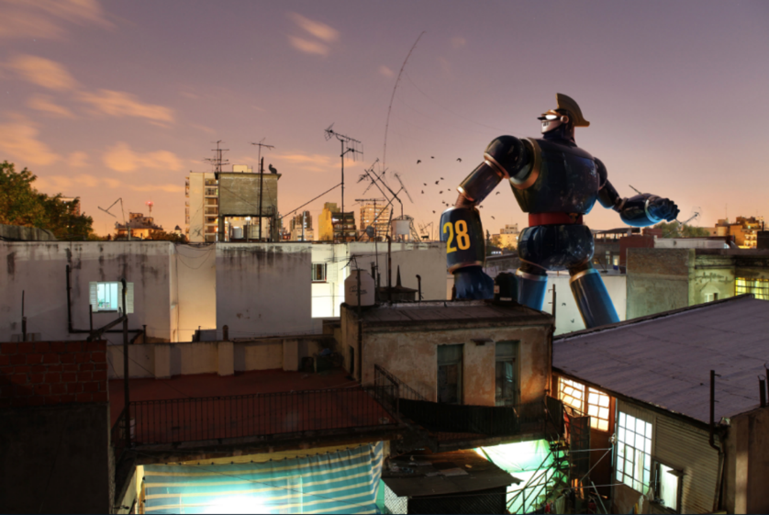
Look at the picture Number 28.
- Answers these questions.
  - Who/what is Number 28? What is his mission? Where has he come from? Who is he speaking to?
  - Do robots have feelings? Will there be robots around in the future?
  - If we all had a personal robot that belonged to us, would this be a good thing or a bad thing?
  - Does a robot need to eat food, or do they need fuel?
  - What is the difference between fuel and food?

- Can you write a sentence that uses an apostrophe for omission?
  - E.g. cannot = can’t I have = I’ve he will= he’ll she is= she’s we have= we’ve will not = won’t
As Number 28 stomped through the town, he couldn’t find what he was looking for.

- Can you write a sentence that uses an apostrophe for possession?
  - E.g. Number 28’s enormous feet crashed onto the ground with a colossal THUD!

- Can you design a robot? Think about what it looks like, and what things it can do!

