25th August 79A.D.
Written by C.Pickering
Last night, the city of Pompeii was left destroyed after an active volcano, Mount Vesuvius, erupted killing two thousand people.
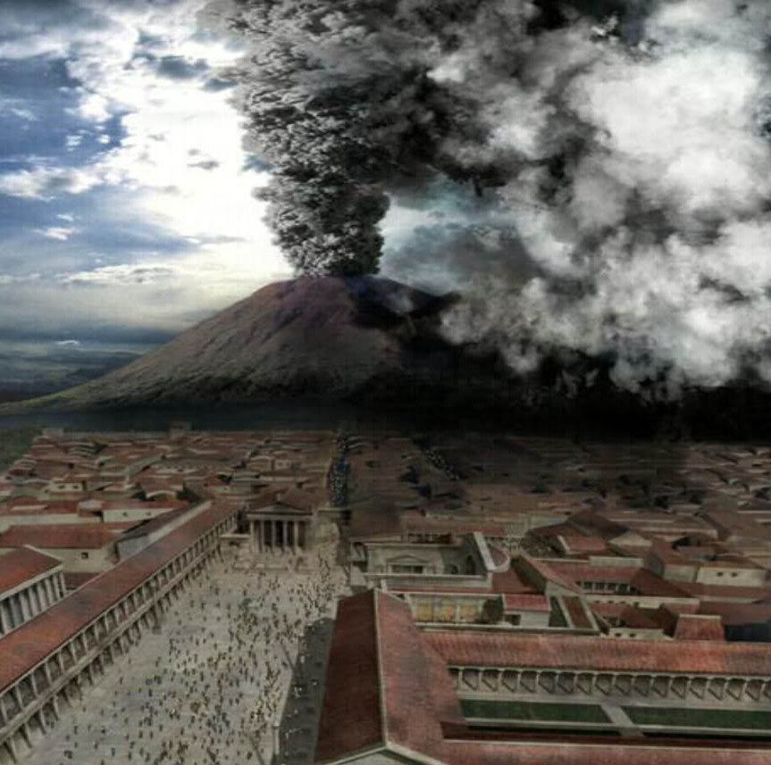
The first warning signs began at 6pm yesterday evening when a tower of black smoke was spotted over the volcano. Soon after, a wave of hot ash, rocks and gasses began to rain down over the North side of Pompeii. After that, the alarm bells were sounded and the city was evacuated.
At around 8.15pm the volcano struck. Boiling lava and burning rocks came crashing from the sky and began to destroy the houses. As it cooled, a tower of debris and ash filled the sky. As more and more ash fell it began to clog the air making it difficult to breath. Men, women and children began to suffocate and were killed instantly by the dense ash.
Next, devastation really hit. A surge of molten rock and superheated poisonous gas poured down the mountain swallowing everything and everyone in its path.
By the time the eruption spluttered to an end early this morning, the whole city of Pompeii was buried under millions of tons of volcanic ash.
Many survivors waited until the dust had settled before returning to search for their family and friends, but there was not much to find. They returned to their homes to find it buried. Pompeii is a ghost town.

Pliny the Younger, a survivor of the eruption, spoke to The Daily Peel: “I believed I was perishing with the world, and the world with me!”

A cloud of ash suffocated thousands of people.

Today, planning has already begun to dig the city from its ruins. Sadly, survivors are not expecting to find anything other than frozen skeletons and household objects.

