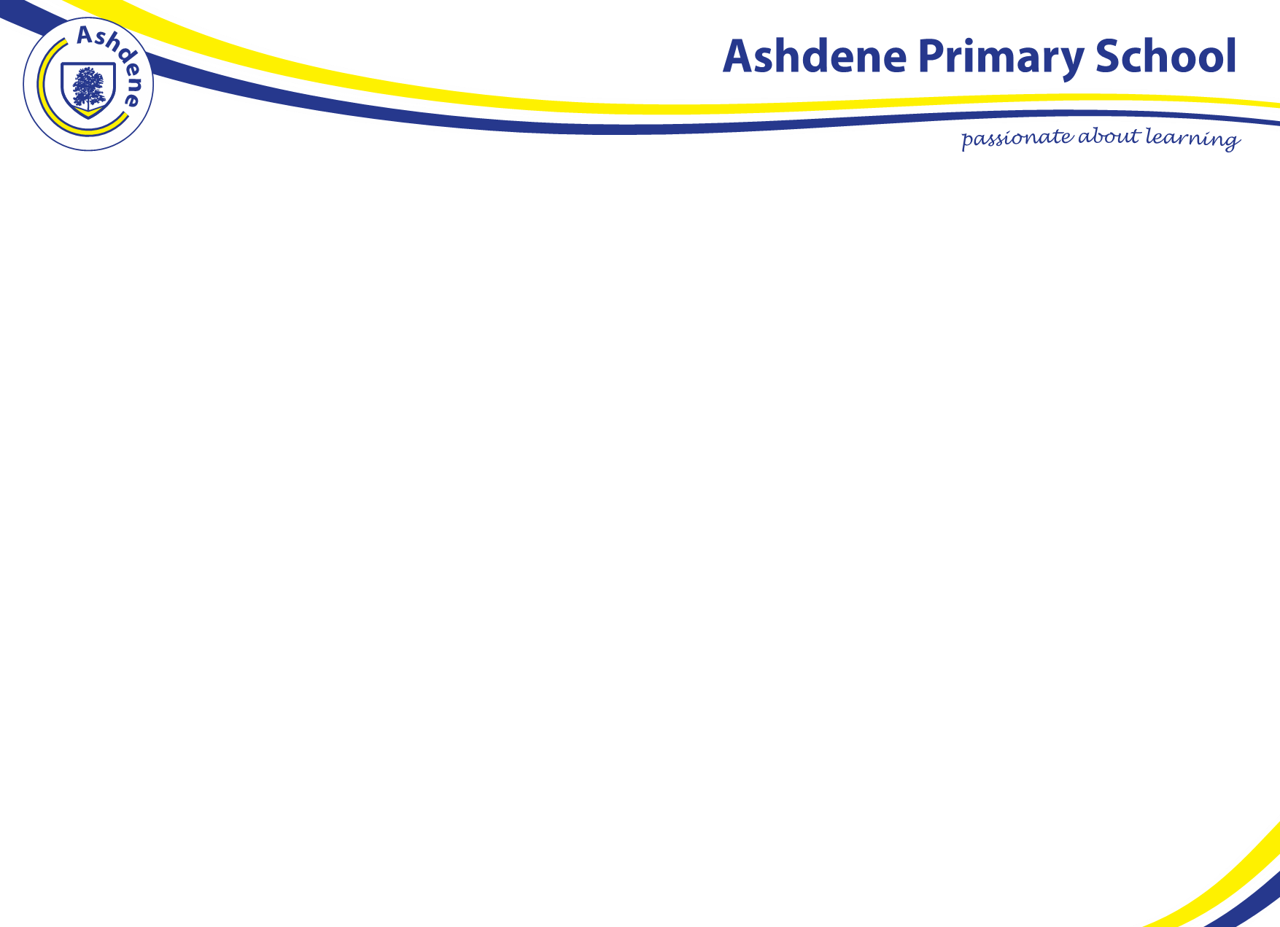

Guided Reading Group 1
Name of book: The Hunt by Emma Lynch (Red – Phase 3 Active Learn Primary)
 | Monday | Tuesday | Wednesday | Thursday | Friday
Learning points prior to reading the book | Focus on the front page, read the title and ask; “What do you think this book will be about?”, “The book is called ‘The Hunt’, what does the word hunt mean?  Back to the book cover – ask “Do you think cats hunt?”  “What might a cat hunt?”  Front cover, hunt, pads, zigzags | From reading the book yesterday and now looking at the front page ask:  “What did we find out about ‘The Hunt’?”  “Which animals was the hunter and which animals were being hunted?”  Introduce the word prey | Now we have read the book a few times, this time we’re going to read it a little bit differently.  Ask children “If I changed the word ‘pads’ to walks how do you imagine the fox to move? What does ‘pads imply?”  See if children can demonstrate what ‘pads’ would look like.  Make a list: travels, sneaks, saunters, runs, patters, marches, creeps, traipses, trugdes, plods, pitter-patters | Share the title with the children again, ‘The Hunt’.  Ask, “Do you know any other animals that hunt?”  “Can anybody remember what the word ‘prey’ means?”  As a group, make a list of the animals that might hunt their prey. | Today is the last time we read this book, discuss whether the book is a story (fiction) or a factual book (non fiction).  Ask the children “What is your favourite part of the book?”  “Do you have a favourite picture?”  Ask the children to explain what their favourite parts are.  Ask “Have you ever seen a fox hunting?”  Discuss why children may not have seen a fox and introduce vocabulary like ‘nocturnal’ explaining that they most frequently come out at night.
Learning points when reading the book | Read ‘The Hunt’ in turns.  Stop at Page 2 and ask “What do you think it means by the word ‘pads’?”  Stop at page 6 “What do you think it means by the word ‘zips’?”  Page 9 ask “What might be meant by the word ‘zigzags’?”  Encourage children to segment sounds in each word if needed. Once they gave read the sentence, encourage children to read without sounding it out to develop fluency. | Read the book again. Remember to reread sentences to develop fluency.  If children are struggling to follow, encourage them to follow with their finger or provide a lollistick | When reading this time, encourage children to help to change the word quick. | If possible, partner children up (they must remain at their tables) and they each take it in turn to read a page. Encourage intonation when reading, particularly when they notice are asking questions! Encourage gestures when asking questions. | If possible, partner children up (they must remain at their tables) and they each take it in turn to read a page. Encourage expression and intonation when reading, particularly when asking questions!
Post reading activity | Look at page 16. It says ‘The fox has had no luck… yet’  Ask “What do you think this means?”  Draw a picture of what you think the fox will do the next day.  Can you write a sentence to explain what is happening in the picture? What is the fox doing? | 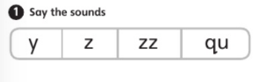  Look back through the book. How many words can you find that include the zz grapheme? What sound does that make again? Ask children to write down the words that they can find in their books. | Look at page 13 and 14. Ask “Why do you think the fox is crouching down?”  Have a think about what the fox might be thinking when he/she is crouching down. Ask the children to share these ideas with the group.  “What do you think the fox might be thinking?” Use powerpoint to model writing a though bubble for the fox. Encourage children to share a sentence and then sound out the words to write it.  Stick sheet into English books.  Ask children to note down any other thought that the fox might have. | Ask children to share their thought bubbles from yesterday so that children know what each other imagined the fox to be thinking, whilst crouching down.  Ask children to look at page 14. Ask “What do you think the hens are saying to each other?”  Point out the difference between thought and speech bubbles.  Model completing a speech bubble and use powerpoint to do this. | Ask children to pick an animal from yesterday’s hunter list.  Ask children to draw a pictur eof an animal watching its prey. Children must label their pictures.
Additional Resources | English book  Pencils | English book  Pencils | English book  Pencils  Fox though bubble sheet | English book  Pencils  Hens speech bubble sheet | May need English books and pencil  Coloured pencils

