Monday Geography resources
The United Kingdom Map
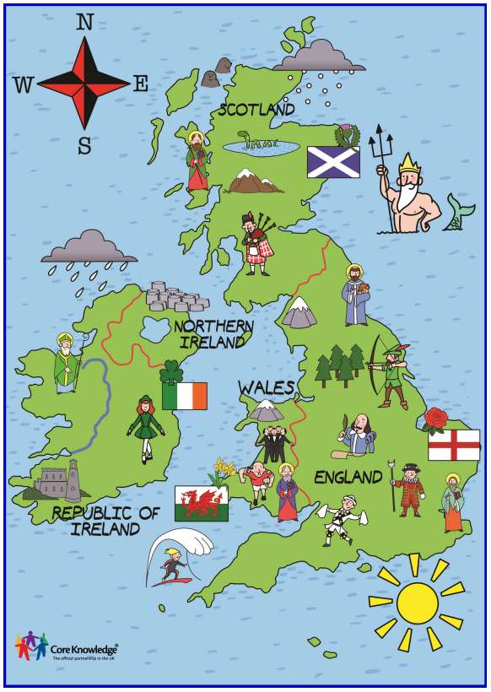

The Creation of the Union Jack

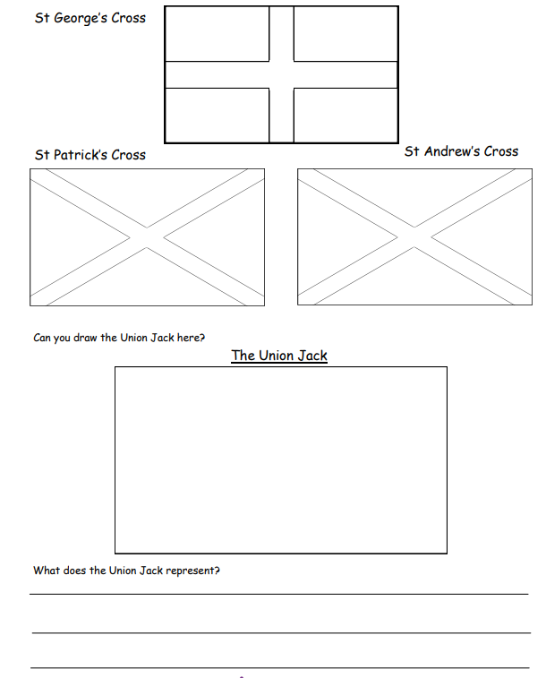

Can you create your own flag?

____________________________________________________________________________
