**Friday Geography resources**

**The United Kingdom Map**

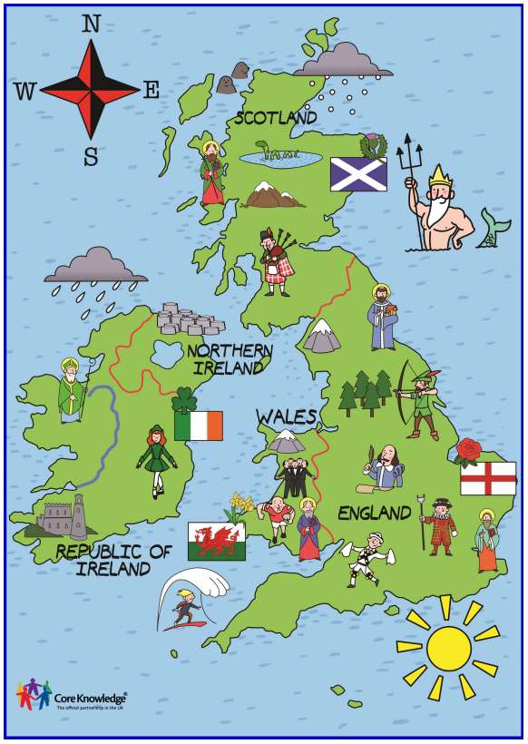

**UK map for teaching**





