Monday

- Look at the front cover of the book the text is taken from this week. Now answer the questions below:
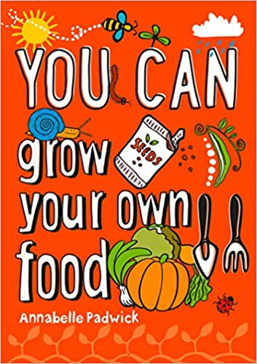
- Do you think this book is fiction or non-fiction? Explain why.
- What do you think the book is about? Explain why.
- Would you like to read this book? Explain why.

- Here is the blurb from the back of the book:
Get muddy, get green fingers and get growing! Always wondered if you could make things grow? This book is what you need to get great at gardening in no time at all. It's easy to understand and tells you exactly what you need to know step-by-step. It offers easy-peasy tips on how to grow all kinds of fruit, vegetables and herbs outside and indoors; has plenty of space to scribble--make notes, keep track of what you have planted and make the book your own; and is packed with fun gardening projects guaranteed to get your hands dirty!
Have you changed your mind about any the answers you wrote above? Can you add anything to your answers? Explain why.

Tuesday

- Read the extract (more than once would be the best).

- If there are any words you don’t understand, look them up using a dictionary or online dictionary.

- Find the following words in the text and match them to the definitions.

compost | To cover in the ground with dirt.
buried | Easy to notice, attracts attention
delicate | A mixture of decaying leaves, vegetables or manure that is used to improve garden soil.
bold | To start or cause something to grow or sprout.
germinate | Easily broken or hurt. Needs to be handled carefully.

- Now decide if these words are nouns, verbs or adjectives.

- Put the words into sentences.

Wednesday
- Reread the text extract again.

- Underline key words in the questions below that will help you find the answers.

- Answer the questions

- When you scoop compost into your pot, how long does the gap have to be at the top?
- What are 2 basic tips when sowing seeds?
- True or false: Big seeds like pumpkins and beans need to be buried deep under the surface, 1-2 cm.
- On page 28, find and copy two adjectives that are used to describe toppings for your pizza.
- Is it easy or hard to grow toppings for your pizza?
- Which topping needs the most sunshine?
- What do pumpkins form on?
- How can you make your pumpkins grow really big?

Thursday

- Read the extract again before answering the inference questions.

- Answer the questions below. Scan the text for key words in the questions to help you find the answers. In the evidence column you can put evidence from the text to support your answer.

- Why is ‘always read the instructions on the seed packet’ described as a basic tip?

- Can you put meat in your pizza garden?

- Would it be a good idea to plant your pumpkin seeds then go on holiday for 2 weeks?

Friday

Today you are going to summarise the text. You need to choose one of the three pages and draw a poster to summarise what you’ve read. The more colourful the better!

