Monday 21st September 2020

Monday 21st September 2020 Exploring the similarities and differences between two stories we have read
Today we read the ‘twisted tale’ The Three Little Narwhals. After working on the traditional tale of The Three Little Pigs for three weeks, we have worked in small groups to compare and contrast the two stories. Here is what we have discovered about the similarities and differences between both texts.
The Three Little Narwhals
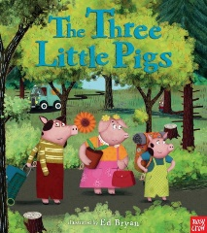
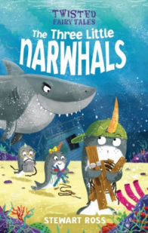
Both
The Three Little Pigs

Contrast

Compare

Contrast

Set in the woods. | 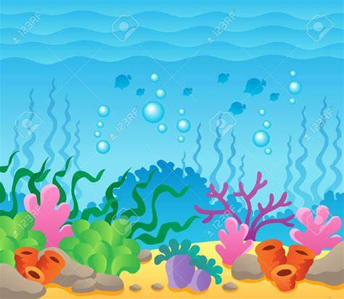  Set in the ocean. | 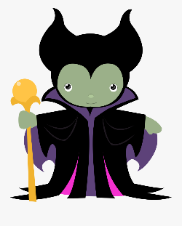  There is a villain. | 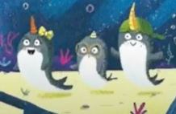  NarWhals.
Pigs. | 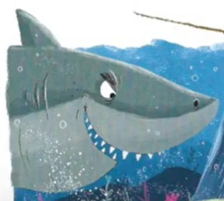  Big, bad shark. | 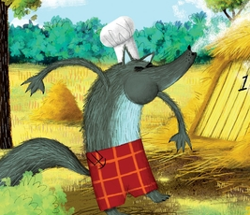  Big, bad wolf. | Three houses were built.
The villain hurts himself. | 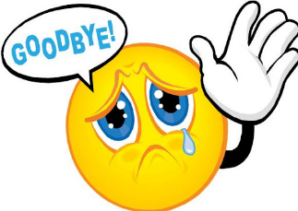  The animals left home. | 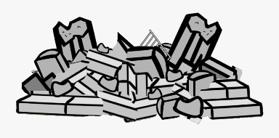  Two houses are knocked down. | 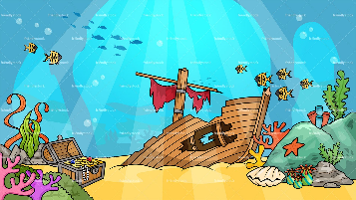  There was a shipwreck.

Tuesday 22nd & Wednesday 23rd September 2020

To be added to website ASAP

Thursday 24th & Friday 25th September 2020

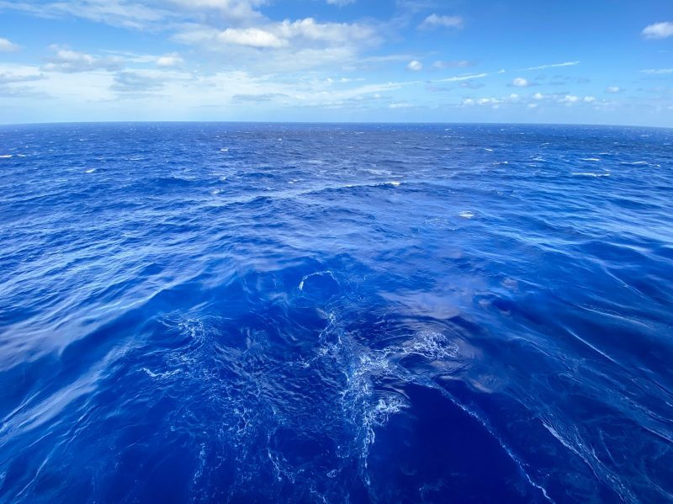

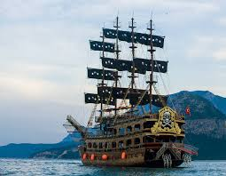

Think of two adjectives for each picture.
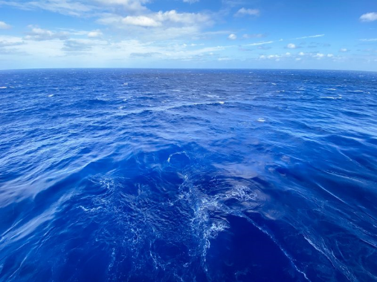
- __________________________________
- __________________________________
sea

- __________________________________
- __________________________________
pirate ship

Now put it in to your amazing sentence opener!

Once, on the ___________________________________, __________________________________
sea, there sailed a ______________________________, __________________________________
pirate ship belonging to some very greedy pirates.

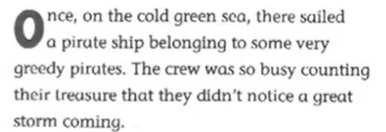
Create your own amazing sentence opener, remembering to
describe the sea and the pirate ship using adjectives.
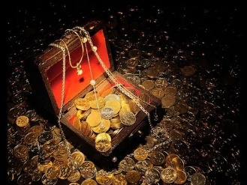
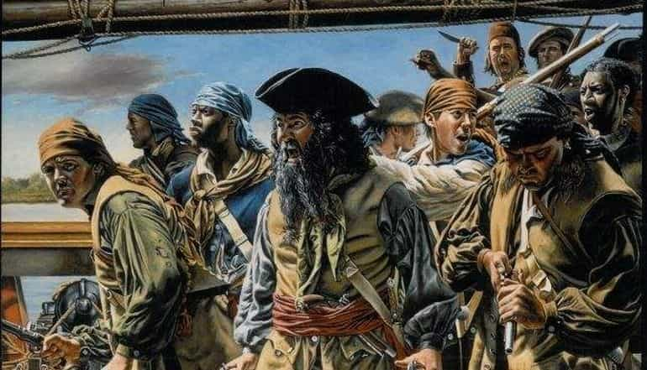
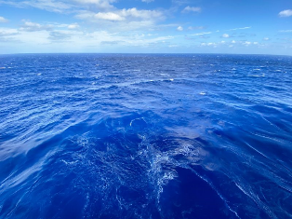
Challenge: describe the pirates and treasure

