Look at the picture

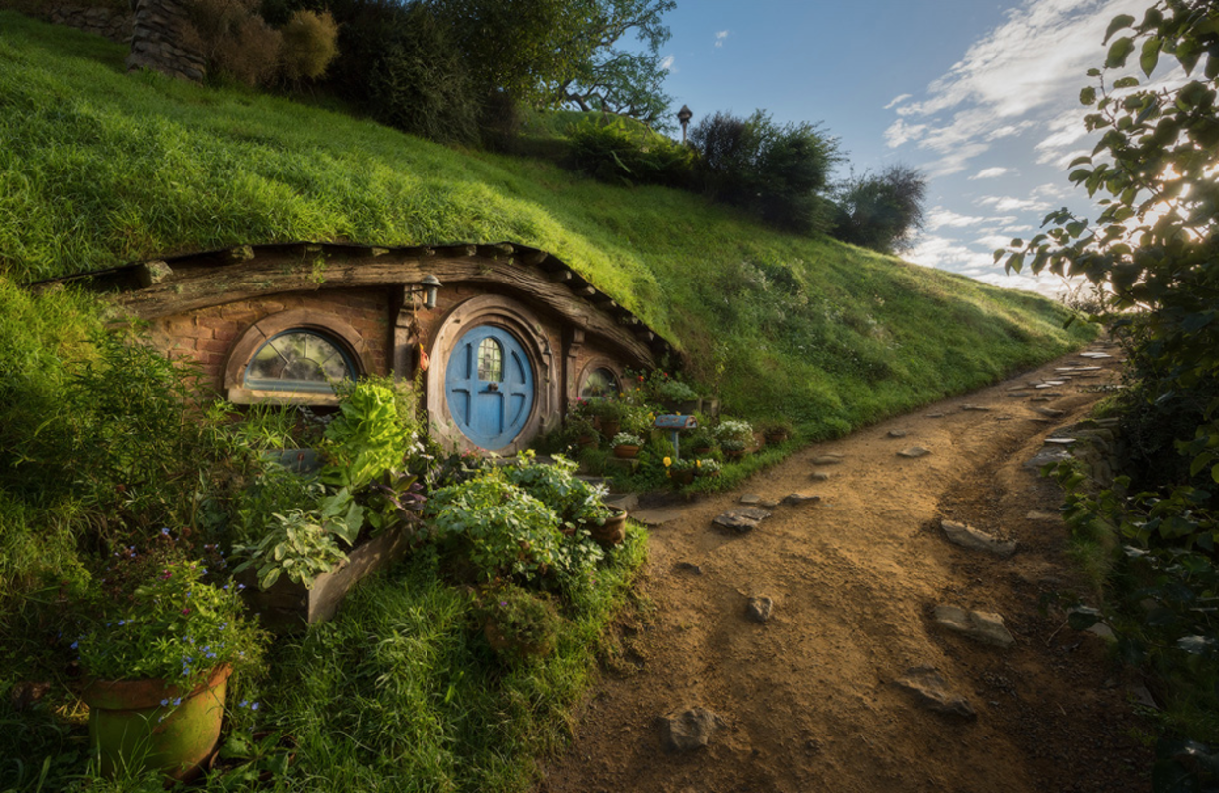

**Task 1** – Think about these questions and answer them in your book.

Who do you think they are?

What do they look like?

Why do you think they like ‘staying out of the limelight’?

Why do they choose to live underground?

How many of them do you think live in this house?

What is it like inside?

Do you think there are other houses like this? Where are they?

**Task 2**

Imagine who/what might live inside this house. Can you draw them?

Are there other houses like this? Can you draw one? You could perhaps draw what one of the rooms inside might look like! Label the things you have decided to include.