Vocabulary Tuesday

- Find the below vocabulary in the extract.

Wisest
Uber
Cafeteria
Geek
Intensively
Dyed
Frescoes
Consultants

- Write down and find the definition for any other unfamiliar words.

- Match the vocabulary you have found in the text with the definitions and pictures below.

Word |  | Definitions
 | A dining hall or restaurant in which customers choose or are served their food at a counter. The customers then carry the food on trays to their tables.
 | A substance that is used to give color to cloth, hair, or other materials.
 | Having understanding and good judgment about what is true or good.
 | A taxi service that you order via an app.
 | Marked by, or relating to intensity.
 | Someone whose job it is to give advice to others on a particular subject; expert.
 | The art of painting on wet plaster with colors dissolved in water or limewater, or a picture produced by this method.
 | a person who is considered to be socially different or awkward, esp. because of being overly intellectual.
Pictures
 | 
 | 
 | 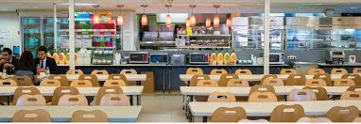
 | 
 | 
 | 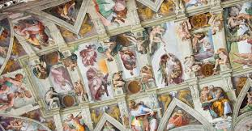
 | 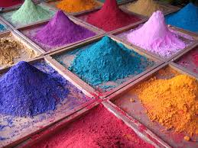
 | 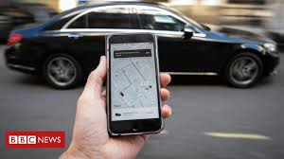

ANSWERS
Definitions
Cafeteria | A dining hall or restaurant in which customers choose or are served their food at a counter. The customers then carry the food on trays to their tables.
Dye | A substance that is used to give color to cloth, hair, or other materials.
Wise | Having understanding and good judgment about what is true or good.
Uber | A taxi service that you order via an app.
Intensive | Marked by, or relating to intensity.
Consultants | Someone whose job it is to give advice to others on a particular subject; expert.
Frescoes | The art of painting on wet plaster with colors dissolved in water or limewater, or a picture produced by this method.
Geek | a person who is considered to be socially different or awkward, esp. because of being overly intellectual.
Pictures
Wise

Geek

Cafeteria

Consultants

Intensive

Frescoes

Dye

Uber

